Project 2

(Report)

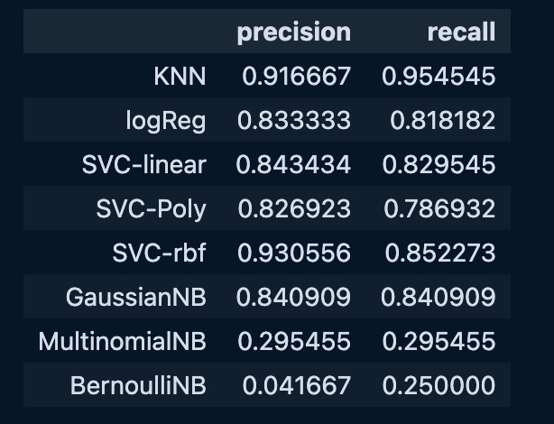

The best Method is KNN because precision and recall (0.916 , 0.954 ) in KNN is higher than other model